1. **generate() and limit()  
   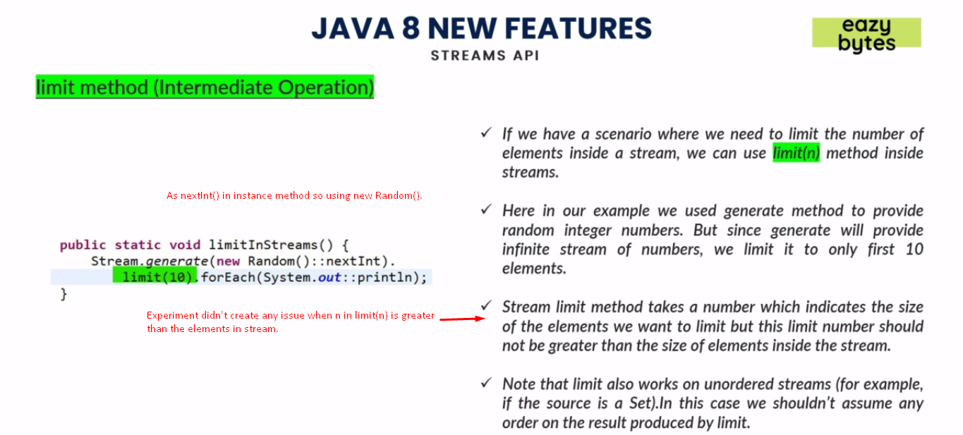**
2. **skip()**
3. 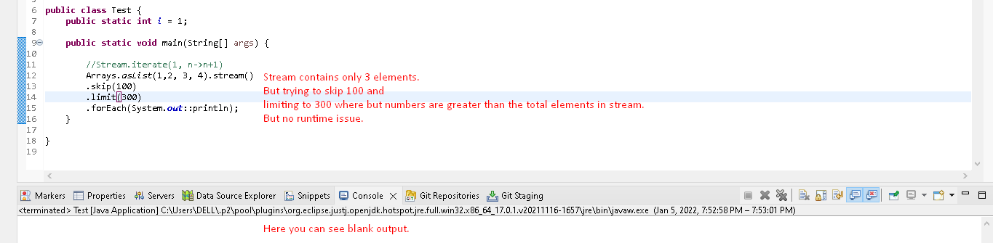
4. **Iterate()**  
   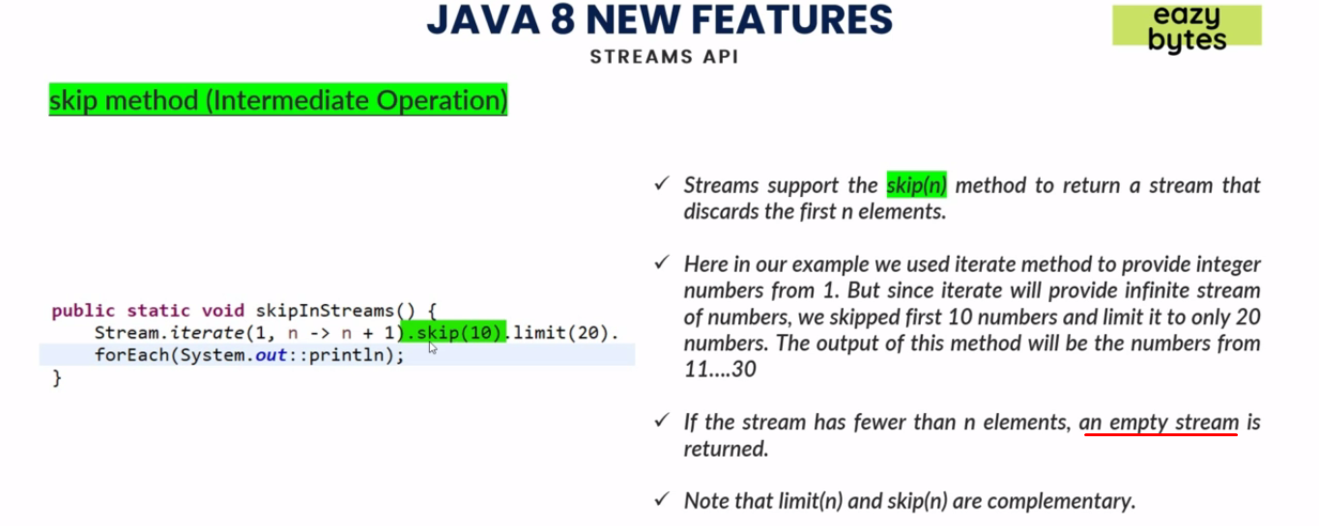
5. **distinct()**  
   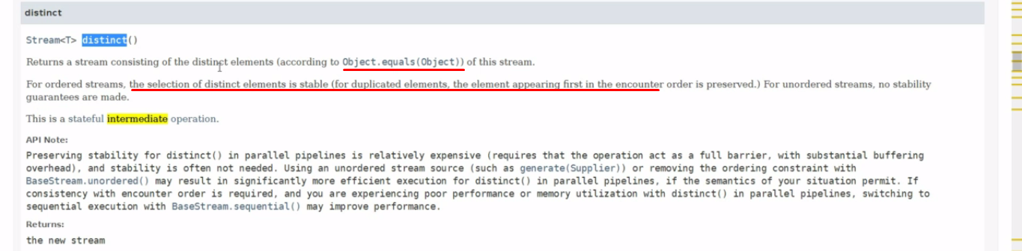
6. **sorted():** Two flavors.  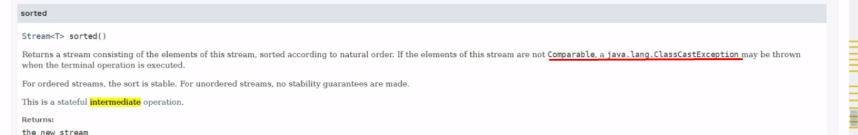  
   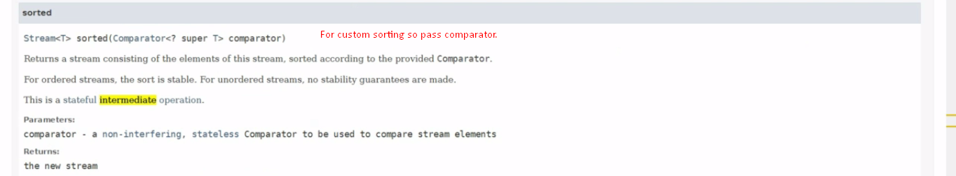
7. **peek()**
   1. For debugging purpose.
   2. After applying the consumer, it will create a new stream consisting of elements in the original stream on which peek(consumer) was called.
   3. If no terminal operation, then consumer passed to peek will not be executed as it is usual with other intermediate operations.
   4. The consumer passed which is called action is non-interfering action   
      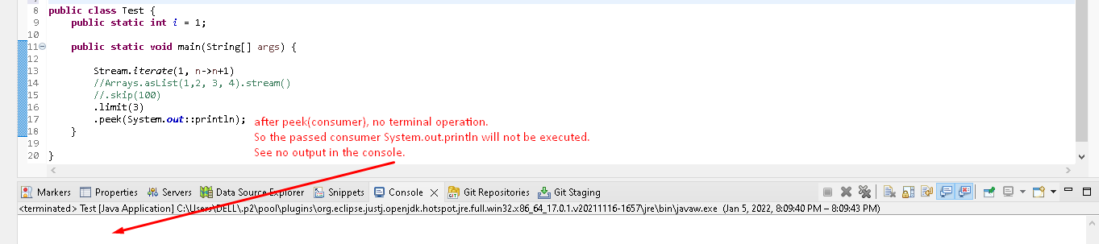
   5. 